ST. MARY’S HOME FOR CHILDREN
PQI QUARTERLY REPORT
Second Quarter: April - June, 2020

Executive Note: The dedication and resilience of our staff never ceases to amaze me. The pandemic may have slowed things down – mostly because we were busy writing and establishing new protocols and ensuring that those who work at home have the technology and resources they need. A focus on safety for those we serve and our staff is our primary concern. Despite ‘slowing down’ a bit, our committees and teams continued to push forward on initiatives and developing resources to which we are committed. You will see the great work that our teams accomplished during this challenging time in this report.
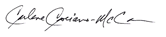

PQI Note: This quarter we continued to meet goals and implement safety protocols so the campus could be re-opened safely and consistent with RI state guidelines. The initial ‘pandemic pivot’ has eased, and we have a better understanding of the impact of the pandemic on staff, clients, the community, agency finances etc. This is allowing us to give proactive attention to matters across all departments and programs at the agency. In ‘PQI language’ we in essence needed to ‘assess the problem, collect the data and make a plan’. It feels good to be in the stage of implementing the plan, and also to have experiences and data to draw from as we unfortunately anticipate another ‘pivot’ ahead as we get into the colder seasons. We continue to rely on our systems in place, and modify them for the short term during the pandemic. It will be exciting to get to the place in time where we can assess which of those systems proves it should be permanent due to added value to staff, clients and the agency.

Contents Page
Initiatives & Action Plan Spotlight: CLAS Standards 2
PQI Committee Reports Highlights of Achievement 2-3
Census Data 4
Clinical Record Audits 5
COVID-19 Business Continuity Highlights 5-6

Initiatives & Action Plans Spotlight: CLAS Standards
As a part of our Strategic Plan, a work group was created to assess practices and facilitate changes needed to effectively and meaningfully implement the national standards for culturally and linguistically appropriate service (CLAS standards) in health care. Implementation of CLAS standards can help improve the quality of services provided to all individuals, help reduce health disparities, and help achieve health equity.

Implementation of the CLAS standards is important to improve outcomes for clients we serve and for our community. According to the RI State Data Center, 1 in 5 residents speak a language other than English at home. The top five languages spoken in RI at this time are Spanish, Portuguese, Chinese, Korean and Vietnamese. 105,155 RI residents speak Spanish or Spanish Creole at home, including 26,377 children ages 5 to 17.

After a pivot due to the pandemic, the work group has begun the assessment process and made progress toward their goals. Specifically, the work group arranged for fourteen (14) Directors, Managers and PQI staff to be trained by Moïse Bourdeau from the Health Equity Institute, Rhode Island Department of Health. A Data Gap Analysis was completed after the training to assist the work group in their continuing efforts. Additionally, resources regarding translation services have been shared among programs, and a self-assessment tool has been obtained to further guide the work group.

PQI Committee Reports Highlights of Achievement
CERT/Safety Committee
- Full virtual meetings; brainstormed campus conditions and re-opening details; shared observations and maintained connection with remote working staff relative to safety.

PQI Committee
- PQI work continues with limited meetings, and work continuing in other venues.
- All intake documents translated into Spanish, with OB/CBS completed and in Best Notes during the quarter, and the remaining programs completed early in Q3 as well.

Risk Prevention and Management Committee
- Finalized and distributed a comprehensive Annual Risk Report for the entire Board, and for in-depth review by the Audit/Risk Subcommittee.
- Approved one additional pet under the Employee Pet Policy.

Critical Incident Committee
- Continued to use data to drive decisions for individual youth during the pandemic.
- A sharp increase in physical restraint was observed and addressed during the quarter, from .8% in March to 2.7% in April, and 4.3% in May.
- Action plans and efforts are noted to be successful as the quarter closed with a rate of 1.6% in June. For context, the rate of restraint in residential programs has not been as high since September of 2017, and in 2019 the rate was only one time higher than 1 at 1.5% in March.

Staff Relations
- Hosted a virtual BINGO night for all staff, with 8 raffle prizes and even more participants.
- Designed and mailed a Staff Appreciation Postcard to show “We are thinking of you”, with artwork created by youth on campus.
- Promoted a raffle connecting employees to the new agency Facebook page.

Wellness Committee
- Wellness work continues outside a formal meeting setting, and have re-introduced a ‘Virtual” Staff Yoga schedule for the upcoming quarter.

LGBTQQ+ Committee
- Facilitated a virtual viewing of ‘Stonewall Forever: A Documentary About the Past, Present and Future of PRIDE’, and Billy Porter’s “A Brief History of Overlooked Queer Political Action”.
- Facilitated an art project embedded in opportunities for education and conversations between staff and clients about Black Lives Matter, Black queer and trans folx, disabled folx, undocumented folx, folx with records, women, and all Black lives along the gender spectrum.
- Published a Spring/Summer Newsletter highlighting the art work created.

School Report: PBIS and Social Emotional Learning (SEL)
- While there are no formal meetings in classrooms at this time, the school continued distance learning and planning for a remote summer program, which includes SEL and PBIS.

Residential & School Improvement
- While there are no formal meetings at this time, communication between the school and residential programs continued to support distance learning.
- Significant effort continued with the on-site teams including clinical, milieu, nursing and psychiatry with extensive planning for individual youth as well as whole House supports.

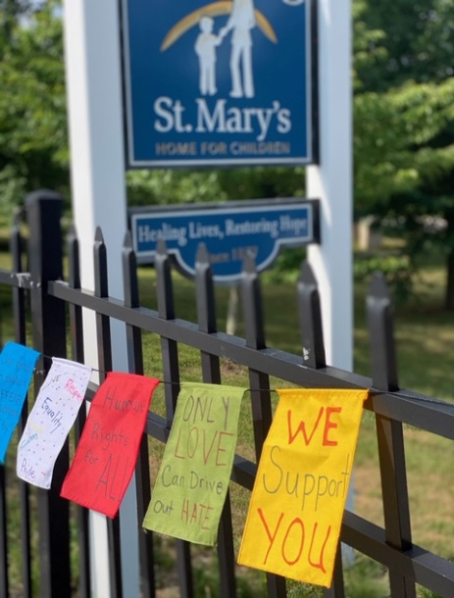
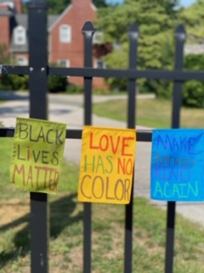
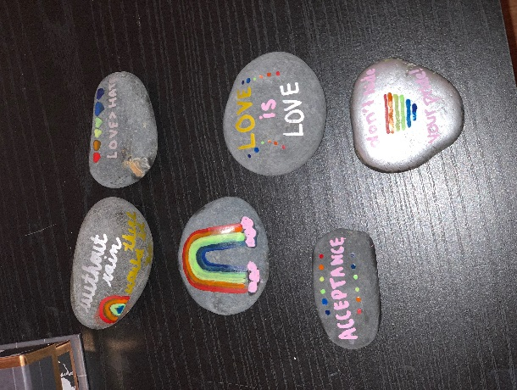

Agency Census Data
Average Agency Daily Census = 286.67
(April = 274; May = 285; June =301)
Data based on Best Notes P – Census Summary Report

Q2 2020 Number of Clients Served by Program
Data based on Best Notes P – Weekly Census Report
Data Quality review and correction of data for reporting 7/7/2020
275 unique individuals, representing 355 clients, served in programs as follows:
Program | Q1 |  | Q2 | Q3 | Q4
ARTS | 13 | 26% | 10
ASC Hills | 14 | 6.9% | 15
BBI Aftercare | 13 | 26% | 10
CFTT | 9 | 20% | 11
Day Students | 24 | 40% | 16
EOS | 42 | 12.6% | 37
Equine | 22 | 51% | 13
FISA | 13 | 47.6% | 8
FISA Group | 17 | 72%  73% | 8
HFH Group | 28 | 87% | 11
MLMC Group | 11 | 75% | 5
Office Based | 120 | 1% | 119
OSP | 3 | 80% | 7
Our Family HFH Group | 6 | EVEN | 6
PRTF Hope | 7 | 15% | 6
PRTF Horton | 9 | 11.7% | 8
PRTF Mauran | 8 | 28.6% | 6
SAE | 6 | 66.6% | 3
SAFFE | 18 | 24.4% | 23
STAAR | 28 | 11.3% | 25
60 clients (22%) participated in two or more programs during Q2

Average daily census data evidences a 13.63% decrease in clients receiving program services, and an 8% decrease in the number of unique individuals served. After a nearly 13% decrease in average daily census from March to April, there were two months of slight increases (4% and 5.6%). The COVID-19 pandemic is assessed as the dominant factor in program census changes. Due to the pandemic, admissions to the agency was closed for approximately 5 weeks, which had a significant impact on the census in our residential programs. During the closure of admissions, agency leadership worked quickly and closely with other members of the RICCF to advocate for guidance from DCYF and RIDOH to enable programs to safely admit residential youth. OB/CBS programs quickly worked on offering services to wait list individuals, and then accepted referrals from the community. Note that the School average daily census has been steady, however there were multiple admissions and discharges recorded in Best Notes in Q1 which makes the data appear skewed.
Clinical Record Audits
Residential Audits (ARTS, Residential, Assessment Center)
- Due to COVID-19 and the previous campus lockdown, the Q1 residential programs audits were performed remotely and 100% by the PQI Specialist. Reporting was greatly expanded, and provided more graphic data to help the program with their improvement efforts.
- 47 records in total were audited, representing 100% of open records during the quarter per DCYF and COA standards. 20 of those records were recently closed.

Community and Office Based Audits
- Due to COVID-19 and the previous campus lockdown, the Q1 office and community based programs audits were performed remotely and 100% by the PQI Specialist. Reporting was greatly expanded, and provided more graphic data to help the program with their improvement efforts.
- 49 records in total were reviewed in compliance with COA percentage guidelines, with 8 of those being recently closed.

COVID-19 Business Continuity Highlights
- Awarded a Payroll Protection Program loan, which will be forgiven for appropriate use of funds;
- Awarded a 50,000 grant from the RI Foundation’s COVID Response Fund, to be used for expenses related to the pandemic;
- Finalized an Agency COVID Control Plan, with 14 related Protocols to support the safe re-opening of campus. The Plan includes all criteria required by Re-Open RI, input on protocols from DOH and DCYF, and our own standards for safety. The full Plan and related agency-wide Protocols are available electronically or hard-copy to anyone who wants (see PQI department), and are available on a new COVID folder on the Public Drive;
- The Campus lockdown to essential campus-based staff was lifted on June 1st, with the majority of returning staff starting on campus June 15;
- The Control Plan and Protocols were presented in a training for all staff working on campus. This was the first major campus based ‘virtual’ training, which utilized Gemma and the renovated Library. Note: the Library furniture and technology are now being assessed for durability, comfort and quality to help inform decisions regarding the upcoming Gemma renovation;
- A Public Health Disclosure handout with acknowledgement was implemented to ensure clients are aware of our legal obligations to disclose information to public health officials given the possibility of contact tracing during the pandemic;
- OBS group therapy started successfully in a telehealth setting with privacy practices in place;
- An Office & Community Based Programs Re-Opening Phases Plan was finalized, with limited face-to-face sessions in the community for clients not responsive to telehealth in Phase One which started late May. Phase Two started July 1, whereby five indoor locations on campus and several outdoor locations on campus and at St. James Church were identified for in-person sessions. The full Plan is available (see PQI department or on Public Drive);
- A School Re-Opening Plan is being finalized according to state guidelines which require a Plan for three scenarios: On-site learning, Distance learning, and a hybrid Plan. The full Plan will be available after state approval (see PQI department or on Public Drive);
- Completed the COA Self-Study submission as scheduled; advocated for a summer Site Visit versus postponing to the fall or winter; on target to submit ‘on-site’ evidence to a HIPAA compliant drop box in lieu of COA review of the materials in person.

